Properties of Matter
- Classify and/or compare substances on the basis of their physical properties and/or explain that these properties are independent of the amount of the sample.
  - Physical property – characteristic of a pure substance that can be observed without changing it into another substance.
    - Ex. appearance, texture, color, odor, melting point, boiling point, density, solubility, magnetism, conductivity
- Describe density and/or calculate and compare the densities of various materials using the materials’ masses and volumes.

m
D v

  - Density - the ratio of mass to volume of a substance

- Conductivity, magnetic properties
  - Conductivity – the rate at which heat and electricity pass through a substance
    - Most common are metals
  - Magnetic properties – the characteristics of a substance to be attracted to a magnet
    - Iron nickel, cobalt – are only metals that have magnetic properties.

- Describe how elements combine in a multitude of ways to produce compounds that make up all living and nonliving things.
  - Compound – a substance made of two or more elements that are chemically combined.
    - Ex. CO_{2,} H₂0
- Solubility (solvent, solute, and saturation)
  - Solubility – how much solute can dissolve in a solvent at a certain temperature
    - Solute - substance that is being dissolved
    - Solvent – substance the solute is dissolving in
    - Saturation – the point at which no more solute will dissolve

- Describe the motion of particles in solids, liquids, and/or gases.
Solid Liquid Gases

- Particles farthest apart
- Particles move much to fill a space
- No definite shape
- No definite volume
- Particles farther apart
- Particles move much freely (flow)
- No definite shape
- Definite volume
- Particles close together
- Particles don’t move much (vibrate)
- Definite shape
- Definite volume

- Explain that elements are grouped in the periodic table according to similarities of their properties.

- Explain that atoms are the smallest unit of an element and are composed of subatomic particles (protons, neutrons, and electrons).

- Identify common examples of acids, bases, and/or salts.
  - Acids – acetic acid, vinegar, hydrochloric acid
  - Bases – soap, antacid, baking soda
  - Salt – (neutral substance) sodium chloride, potassium iodide, calcium carbonate

- Compare, contrast, and/or classify the properties of compounds, including acids and bases.
  - Compounds have different properties than any of the elements that are in them
  - Acids react with metals and carbonates, taste sour and turn blue litmus paper red
  - Bases taste bitter feel slippery and turn red litmus paper blue

- Differentiate among pure substances, mixtures, and solutions.
  - Pure substance – made of only 1 type of element
  - Mixtures- two or more substances that are together in the same place but not chemically bonded (joined)
  - Solution – a mixture containing a solvent and at least1 solute and that has the same properties throughout
Changes in Matter
- Differentiate between physical and chemical changes.
  - Physical change – alters the form or appearance of a material but doesn’t make it another substance
  - Chemical change – a change in which one or more substances combine or break apart to form new substances
- Explain that mass is conserved when substances undergo physical and chemical changes, according to the Law of Conservation of Mass.
  - Law of Conservation of Mass(Matter) – mass is neither created nor destroyed

- Describe how temperature influences chemical changes –
  - Increase temp = increase speed of reaction
  - Decrease temp = decrease speed of reaction
Forms of Energy
- Identify, compare and/or contrast the variety of types of radiation present in radiation from the Sun.
  - Ultra violet shorter wavelength/higher frequency
  - Visible light (ROYGBIV)
  - Infrared (heat) longer wavelength/lower frequency

- Identify and/or compare characteristics of the electromagnetic spectrum. 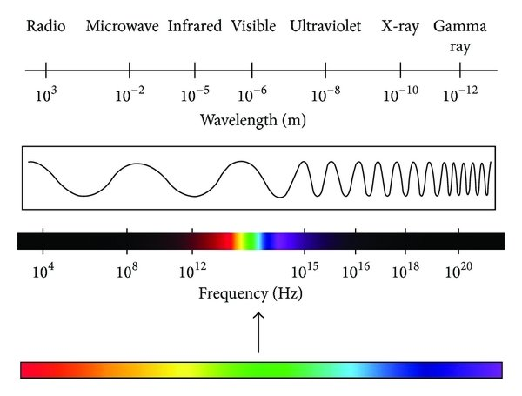
  - Wavelength – distance from 1 point of a wave to the same point on the next wave
  - Frequency – how many waves pass a point in 1 sec.

- Identify common uses and/or applications of electromagnetic waves.
  - Microwaves
  - Heat lamps (infrared)
  - Xrays, gamma rays (medical)

- Order of frequencies and wavelengths in the electromagnetic spectrum - see chart above

- Describe and/or explain that waves move at different speeds through different materials.
  - Waves move fastest in solids and slowest in gases

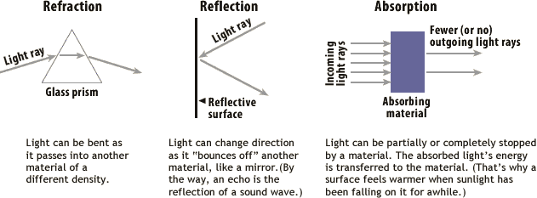
- Explain that light waves can be reflected, refracted, and/or absorbed.

Energy Transfer and Transformations
- Identify and/or describe the transformation of energy from one form to another.
  - Law of conservation of energy – energy can neither be created nor destroyed it can only change form
  - Ex. Lamp (electrical to light and heat); bicycle (chemical to mechanical to kinetic)

- Differentiate between potential and kinetic energy.
  - PE stored energy
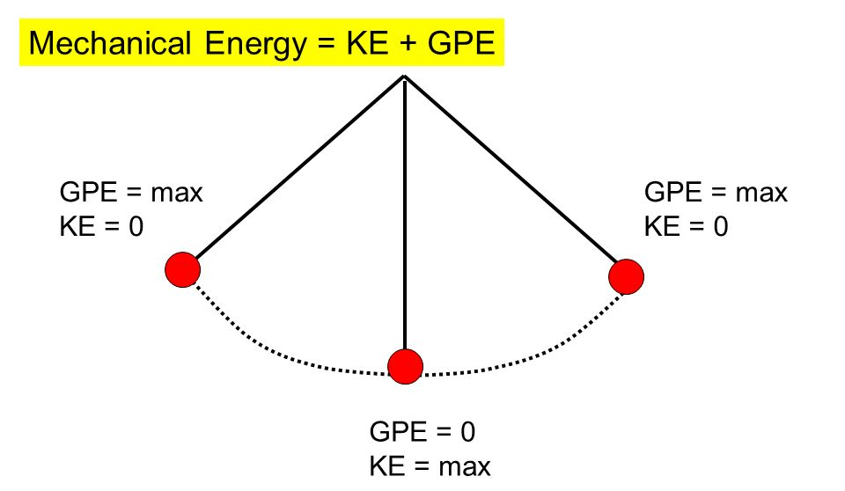
  - KE energy of movement

- Identify and/or explain situations where energy is transformed between kinetic energy and potential energy.

- Identify and/or describe examples of the Law of Conservation of Energy. – see pendulum

- Describe how heat flows in predictable ways.
  - Law of thermal Equilibrium Thermal energy travels from hot toward cold seeking balance

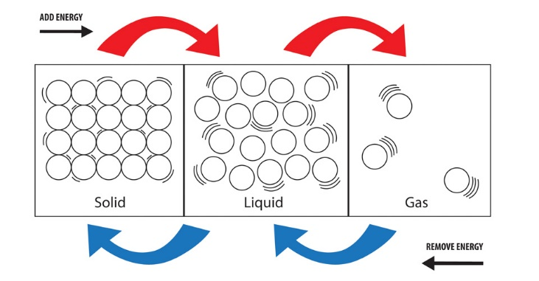
- Explain that adding heat to or removing heat from a system may result in a temperature change and possibly a change of state.

- Heat transfer (conduction, convection, radiation)
  - Conduction – transfer by contact
  - Convection – transfer by movement (hot rises, cold sinks)

- Specific heat - the heat required to raise the temperature of the unit mass of a given substance 1 degree celcius
Forces and Changes in Motion
- Identify and/or describe types of forces.
  - Balance force
  - Unbalance force

- Describe the relationship among distance, mass, and gravitational force between any two objects.
  - Increased distance decreased gravitational force
  - Increased mass, increased gravitational force

- Differentiate between mass and weight.
  - Mass is a measurement of the amount of matter something contains,
    - measured by using a balance comparing a known amount of matter to an unknown amount of matter
  - Weight is the measurement of the pull of gravity on an object
    - measured on a scale.

- Law of Universal Gravitation (mass/distance)
  - ALL objects attract each other with a force of gravitational attraction.
  - force of gravitational attraction is directly dependent upon the masses of both objects
  - inversely proportional to the square of the distance that separates their centers.

- Describe and/or explain that an unbalanced force acting on an object changes its speed and/or direction.
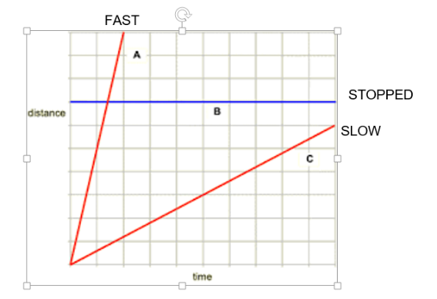
- Interpret and/or analyze graphs of distance and time for an object moving at a constant speed. Ex. relative speed of an object at various points or sections of the graph and the direction of motion

- Net force (direction)

- Changes in speed (positive acceleration and negative acceleration)

- Friction (sliding and stationary)
  - Sliding = moving
  - Stationary = not moving

