Organizing Data Notes
Empirical Evidence: information found during an investigation
Is the evidence empirical? Must answer yes to these questions
Can the investigation be repeated?
Yes! Did the investigation include a hypothesis?
Did the investigation include a procedure and materials list?

Organizing data
Charts – used to help track descriptions and measurements (looks like )
Graphs – used to track numerical (number) data (looks like L )
- Shows a relationship between variables
PRACTICE
Students were given a set of cards containing different species of living organisms and the following directions:
Use the information on the cards to group the organisms into domains, and then into kingdoms. Each card contains shows a picture of the organism and the following information: the number and type of cells that make up the organism, the mode of locomotion, and what the organism uses for food. Begin by constructing a table to collect information from the cards
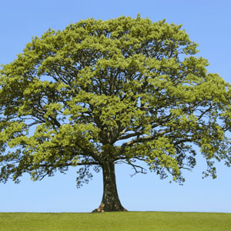
Oak tree: multicellular, cells contain a nucleus, responsive movement only (for example, to light or gravity), uses sunlight to produce its own food.
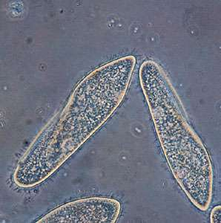
Paramecium: unicellular, nucleus in cell, uses tiny hairs to move in liquid, eats nutrients for food.
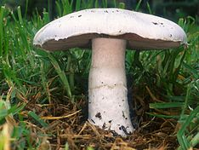
Field mushroom: multicellular, cells contain a nucleus, responsive movement only (for example, to gravity), absorbs nutrients for food.

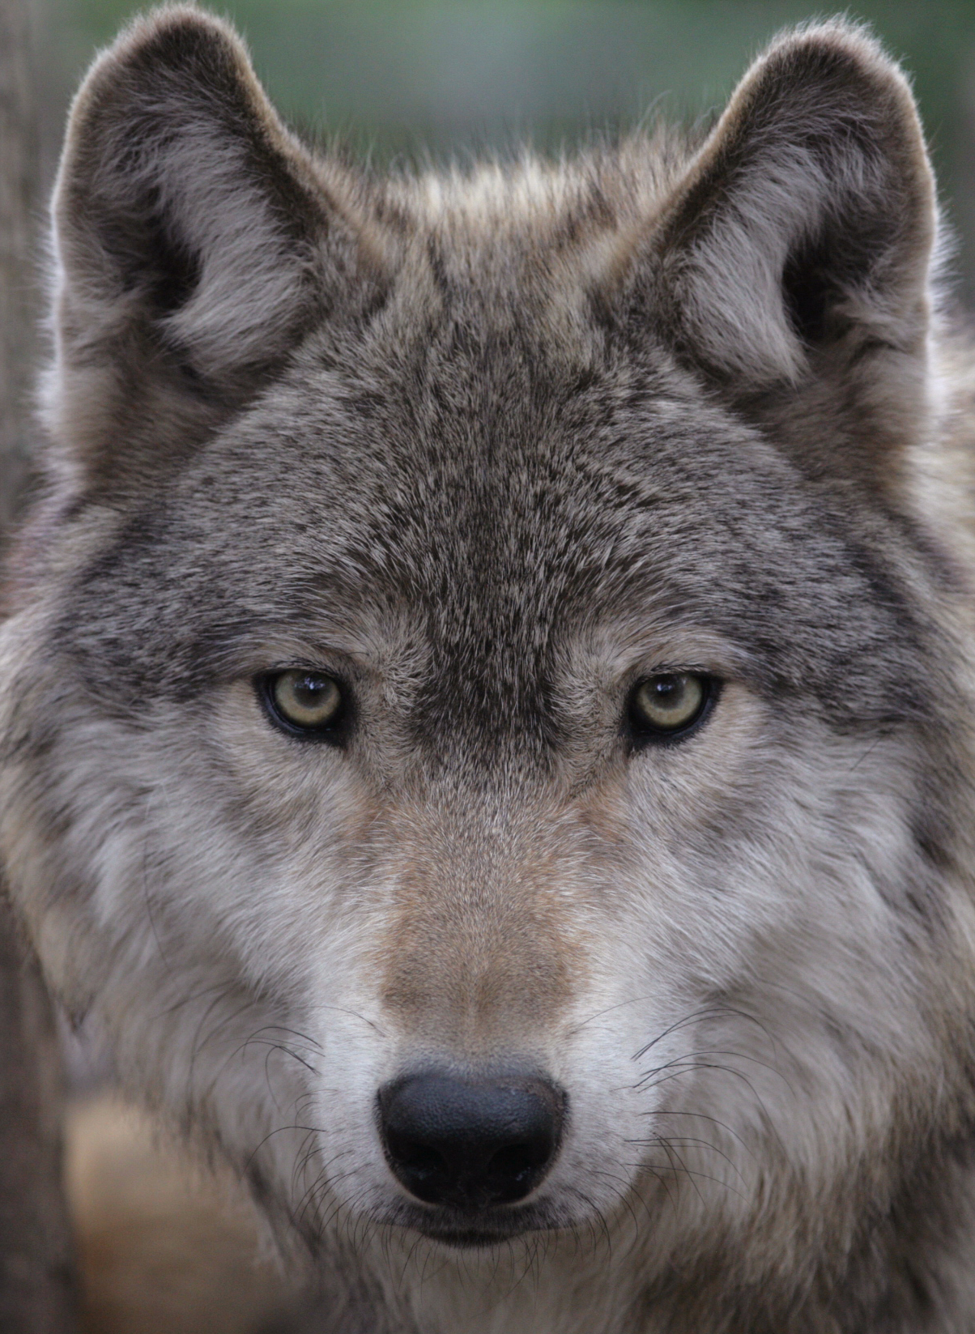
Gray wolf: multicellular, cells contain a nucleus, walks or runs, eats small animals for food.

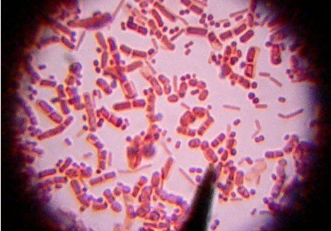
E. coli bacteria: unicellular, no nucleus in cell, can move with a circular motion in liquids, eats nutrients for food

Chart
 | Wolf | E coli. | Oak tree | Paramecium | Mushroom
# of cells | many | One | Many | One | Many
Do cells have a nucleus | Yes | No | Yes | Yes | Yes
What does it use to eat | Small animals | Nutrients | Sunlight | Nutrients | Nutrients
How does it move? | Walks/run | In liquid | Responsively | In liquid | responsively

Graph
5
4
3
2
1
 | 1 cell | Many cells | Move responsively | Eats nutrients | Cells have nucleus | Moves by walking

