Charts and Graphs
Students were given a set of cards containing different species of living organisms and the following directions:
Use the information on the cards to group the organisms into domains, and then into kingdoms. Each card contains shows a picture of the organism and the following information: the number and type of cells that make up the organism, the mode of locomotion, and what the organism uses for food. Begin by constructing a table to collect information from the cards
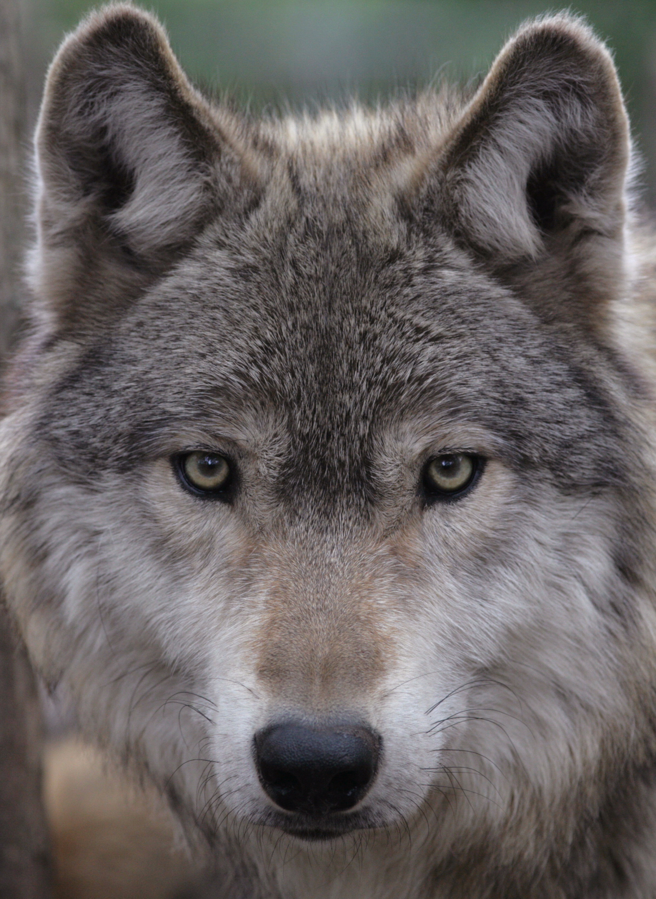
Gray wolf: multicellular, cells contain a nucleus, walks or runs, eats small animals for food.

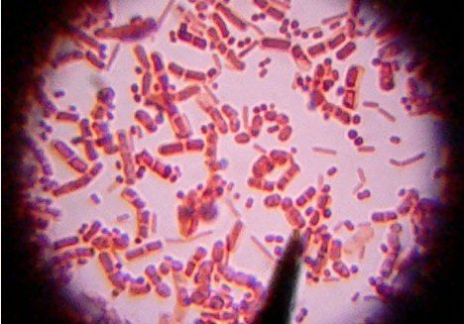
E. coli bacteria: unicellular, no nucleus in cell, can move with a circular motion in liquids, eats nutrients for food
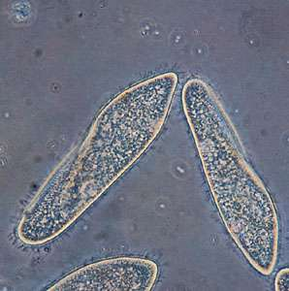
Paramecium: unicellular, nucleus in cell, uses tiny hairs to move in liquid, eats nutrients for food.
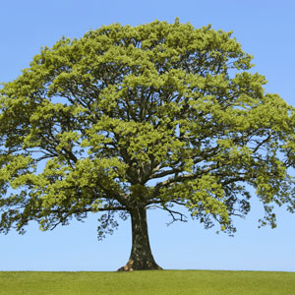
Oak tree: multicellular, cells contain a nucleus, responsive movement only (for example, to light or gravity), uses sunlight to produce its own food.
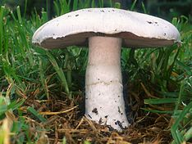
Field mushroom: multicellular, cells contain a nucleus, responsive movement only (for example, to gravity), absorbs nutrients for food.

