Chapter 6 – Waves

Wave – A wave is a traveling disturbance that moves through space and matter. Waves transfer energy from one place to another, but do not move matter.
Medium - The medium is the matter that a wave travels through.
Wave Speed:
Wave move at different speeds in different mediums.
Fastest in solids, slowest in gases
Higher temperature = faster speed
Higher density = faster speed
Higher elasticity = faster speed
*SPEED OF LIGHT NEVER CHANGES!
Mechanical Waves Electromagnetic Waves
Must have a medium** to travel through Can travel through empty space
Vibrations Oscillation
Ex. Sound waves, water waves Ex. radiowaves, x-rays, u.v rays, visible light, gamma rays, micro waves

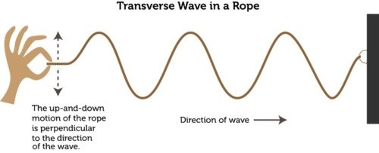
Transverse waves : a wave where the disturbance moves perpendicular to the direction of the wave. Water waves are transverse waves.

Parts of a transverse wave (water waves)
Crest – top of wave
Trough – bottom of wave
Amplitude – from rest position (middle) to top of a wave or from rest position to bottom of a wave
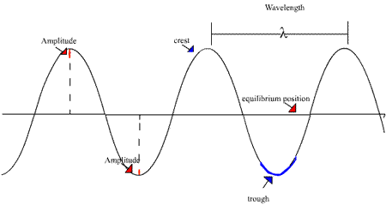

Rest position

Wavelength - the distance between two corresponding points on back-to-back cycles of a wave. Ex. From the crest of one wave to the crest of the next wave.
Frequency - the number of times that a wave passes a point in 1 second.

Longitudnal wave: A longitudinal wave is a wave where the disturbance travels in the same direction as the wave. Sound waves are longitudinal.
Parts of a longitudnal wave
compression: place in a wave where there the pulses are close together
rarefaction: place in a wave where the pulses are farther apart
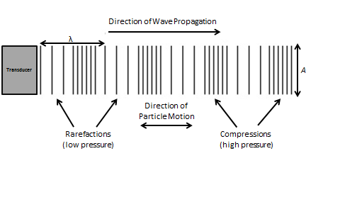
wavelength: distance between two compressions or two rarefactions

