Ch 24 DNA and Replication
- DNA (deoxyribonucleic acid) –
  - About
    - Material that carries the information about an organism from one generation to another
    - Found in the chromatin in the nucleus
    - Looks like a twisted ladder
    - Made up of nucelotides
      - Nucleotides
        - Made of 3 parts
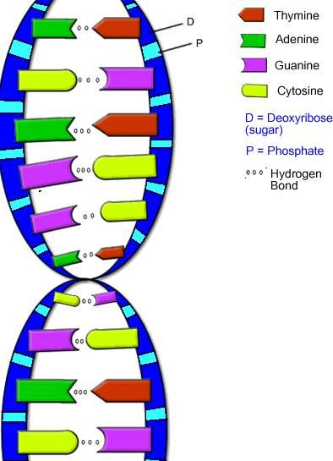
          - 5- carbon sugar = deoxyribose
          - Phosphate group (sides of ladder)
          - Nitrogen base (rungs of ladder)
            - 4 kinds
              - Adenine
                - Only pairs with thymine
              - Thymine
              - Guanine
                - Only pairs with cytosine
              - Cytosine
- DNA Replication –
  - Process
    - a DNA molecule unzips between nucleotides
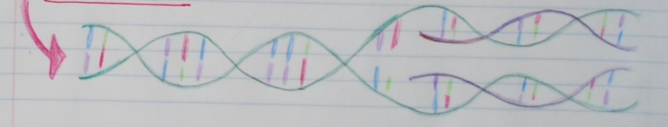
    - new bases pair up with unzipped bases

