Ch. 19 Ecosystem Energy and Matter
Notes

Essential Question: How does energy and matter move through an ecosystem?
I. Ecosystem Roles
A. Producer –
1. makes its own food
2. turn carbon dioxide, sunlight and water into food
3. source of all food
B. Consumer
1. obtains energy by feeding on other organisms
a. herbivore - eats plants
b. carnivore – eats meat
c. omnivore – eats plants and meat
d. scavenger – eats dead organisms
C. Decomposer
1. break down biotic wastes and dead organisms
2. return raw materials (carbon, nitrogen) to ecosystem
II. Energy Flow – energy moves through an ecosystem when organisms eat each other
A. Food chain –
1. one path along which energy can move through an ecosystem
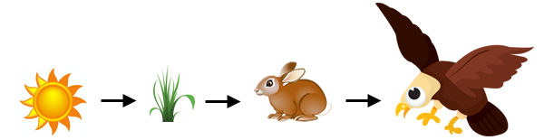

Energy producer primary consumer secondary consumer

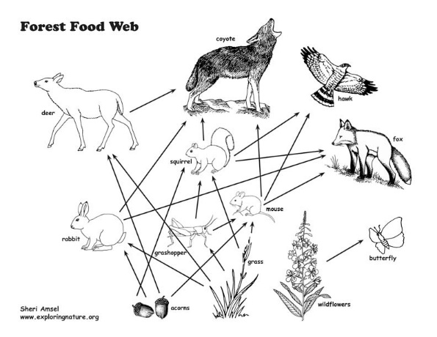
B. Food Web
1. many over-lapping food chains.
2. organisms can have many roles
a. mouse eating grass = primary consumer
b. mouse eating grasshopper = secondary
consumer

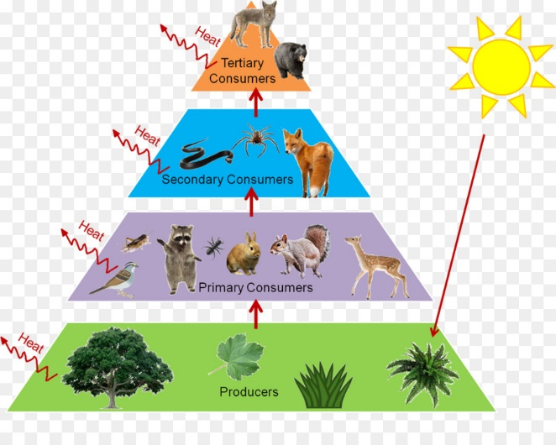
C. Energy Pyramid
1. Diagram that shows the amount of energy that moves from one feeding level to another
2. As you go up the pyramid there is less energy
3. 90 % of energy is changed to heat by organism at each level
4. Producer level = most energy
5. greatest number of organisms = producers
Least number of organisms = highest level

