Ch. 16 Determining Earth’s Age Notes
Essential Question: How do we know how old earth is?
- Uniformitarianism – the same geologic processes that happen today, happened in the past.
- Fossils – preserved remains or traces of living things that lived in the past (organisms die and are buried by sediments
  - Type of Fossils
    - Mold – a hollow area in the sediment which shows the shape of an organism or a part of an organisms
    - Cast – solid copy of the shape of an organism
    - Petrified fossil – fossil in which minerals replace all or part of the organism
    - Carbon film fossil – extremely thin coating of carbon on rock
    - Trace fossil – provide evidence of the activities of ancient organisms (footprint, spoor)
    - Amber, tar, ice – can preserve the remains of organisms with little or no change in the organism
  - Fossil Record
    - Provides evidence about
      - History of life on Earth
      - Changes to groups of organisms over time
      - Past earth environments
      - Theory of evolution (gradual change in living things over long periods of time)
- Age of Rocks – to find the age of a fossil you can find the age of the rock it is found in.
  - Relative age – compared with ages of other rocks around it
    - Index fossils
      - Widely distributed
      - Organisms existed for brief time
      - Help tell the relative age of rock layers
    - Unconformities – gap in the geological record where some rock layers have been lost because of erosion
  - Absolute age – number of years since rock was formed
    - Carbon Dating – determines amount of a radioactive substance is in a rock.
      - Radioactive decay - process by which radioactive substances break down into other substances
      - Half-life – the time it takes for half of radioactive substance to decay.

  - Law of Superposition – in undisturbed rock layers the oldest layer is at the bottom, each higher layer is younger than the layer below it.
F
Older Younger
Limestone
Basalt
Mudstone
Pleistocene Era Beach Sand
Recent beach sand
E
D
C
B

A
Dolomite

- Cross-cutting – any feature that cuts across a section of layered rock is younger than all the layers it cuts through

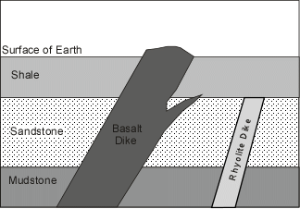
A
B
C
D
E
Oldest __A___
__C___
__D___
__E___
Youngest __B___

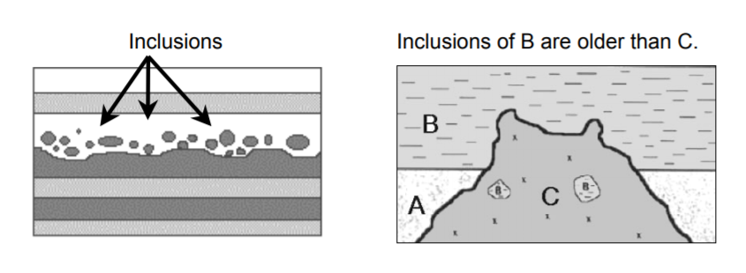
- Inclusions – if a layer contains any pieces of other rock they are older than the rock it is in.

Inclusions D and E are older than C
E
D
Layer B and A are older than C

