Ch. 16 Determining Earth’s Age
Key Terms and Questions

Essential Question: How do we know how old earth is?
Key Terms
- Fossil
- Relative age
- Index fossil
- Carbon Dating
- Radioactive decay
- Law of Superposition
- Cross-cutting
- Inclusions
Key Questions
1. What evidence does the fossil record provide evidence for?
2. What makes a fossil an index fossil?
3. Describe the difference between relative age and absolute age of rocks.
4. How is relative age of a rock determined?
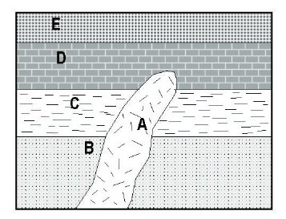
5. How is the absolute age of a rock determined?
6. Look at the diagram to the right. List the rock layers in the correct order from oldest to youngest.

