Ch 14 - The Rock Cycle Notes
- Classified (grouped) according to
  - Type of mineral
  - Color
  - Texture (look and feel of the grains (bits of minerals)in the rock
    - Grain size
    - Grain shape
    - Grain pattern
- Rock Groups
  - Igneous – formed when magma or lava cools and crystalizes (process in which particles dissolved in a liquid solidify in a neat, repeating pattern. Each part of the pattern is a crystal.
    - Ex. Granite, pumice, obsidian
  - Sedimentary – rock material that forms bits of eroded rock are pressed or cemented together
    - Ex. Sandstone, limestone, coal
  - Metamorphic – rock that is changed by heat, pressure or chemical reactions
    - Ex. Slate, marble
- The Rock cycle – slow, continuous cycle change on kind of rock into another kind of rock.
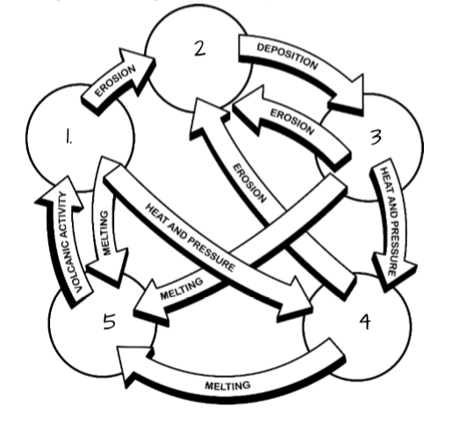
  - Erosion – broken rock materials called sediments are carried away by wind or water
Sediments
Sedimentary
Rock
  - Deposition – moving sediments are dropped where they become
Igneous Rocks
    - Compaction – when rocks are press together by weight of rock above it to make new rock
    - Cemented – rock particles become glued together when dissolved mineral solutions dry and harden to make a new rock
Magma and lava
Metamorphic Rock
  - Volcanic activity – movement of melted rock from mantle to the surface.

