Ch. 15 - The Rock Cycle
Key Terms and Questions
Essential Question: How are rocks formed and how do they change?
Key Terms
- Erosion
- Deposition
Key Questions
- How are rocks classified?
- When describing the texture of a rock, what characteristics of the grains do you describe

- Describe sedimentary rocks.
- Describe igneous rocks.
- Describe metamorphic rocks
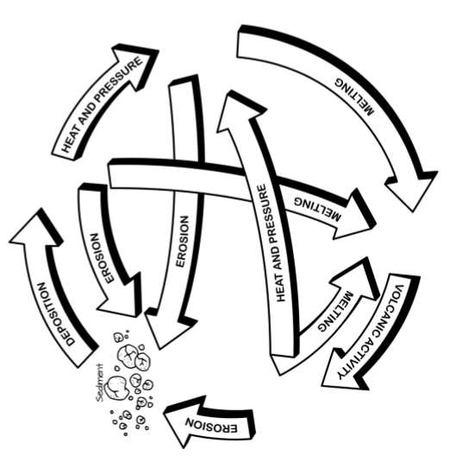
- Fill in the rock cycle below

- Using the diagram of the rock cycle on the previous page, by what process is igneous rock formed?
- Which types of rocks are eroded into sediments?
- By what process are sedimentary rocks formed?
- By what process are metamorphic rocks formed?
- By what process are igneous rocks formed?
- By what process are rocks changed into magma or lava?
- What type of rocks can be changed into sedimentary rocks?
- What type of rocks can be changed into igneous rocks?
- What type of rocks can be changed into metamorphic rocks

