Ch. 9 Earth’s Interior
Key Terms and Questions
Key Terms
- Geologist
- Direct evidence
- Indirect evidence
- Crust
- Ocean crust
- Continental crust
- Mantle
- Lithosphere
- Asthenosphere
- Lower mantle
- Core
- Outer core
- Inner core

Key Questions
- What two types of evidence do geologists used to learn about Earth’s interior and give examples of each?

- What are the three layers of the Earth?

- Using the chart compare and contrast all the layers of the Earth.
Earth’s Layers | Description | Located Between | Order of Density*** | Composition
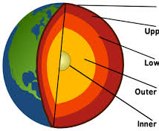
*** 1 = least dense 7= most dense
- Label the diagram of Earth’s Interior.

