Ch. 8 Light and Optics
Light
- Type of electromagnetic wave
- Can travel through space
- Speed = 300,000 km/s in a vacuum
  - Changes in different mediums
    - Fastest = gas, slowest= solid
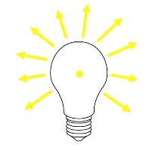
- Light ray – beam of light travels in straight lines
- Light source – anything that emits light
  - light travels in all directions from a source
Light Interacting with media (mediums)
- Interactions
  - Absorbed – soaked up
  - Reflected – bounce off
  - Refracted – bent (this is why you can see objects)
  - Transmitted – go through
    - Transparent objects: let almost all light through
    - Translucent objects: let some light through
    - Opaque: allows no light through.

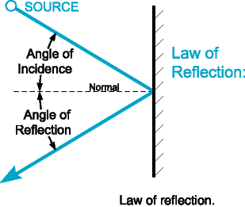
- Law of Reflection – the angle the light approaches a surface = the angle the light reflects from the surface.
  - Angle of incidence (angle of incoming light)
  - Angle of reflection (outgoing light)

- Reflection surfaces
  - Flat shiny surface = virtual image (look like original)
    - Called regular reflection
  - Dull/rough surface = scatter the light fuzzy image or no image at all
    - Called diffuse reflection
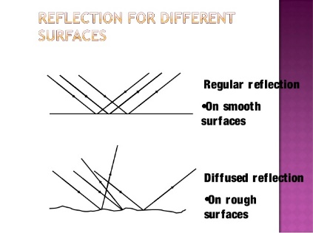
    - Scatter – make light traveling in 1 direction travel in many directions

- Refraction – caused by change in speed of light as it enters different media
  - The more the speed changes = the more light ray changes directions (bends).
Optics
- Mirrors – reflecting surface that forms image
By regular reflection
  - Plane mirror – flat reflective surface
    - Reverse image
    - Image size depends of distance object is from the mirror
      - The farther from the mirror the smaller the image

  - Concave mirror – reflective surface curved inward
Shiny side
    - If object is beyond 1 focal
Focal point – the point at which light ract are reflected
Optical axis
length, the image appears upside
down, smaller
B
    - If object is at 1 focal length image appears upside down, same size as original
A
D
C
    - If object is within 1 focal length, image appears upside down and larger
Focal length – the distance between the focal point and the center of the lens
    - If object is at focal point – no image.

Shiny side
- Convex mirror – reflective surface curved outward
Image: virtual
Right side up
smaller

- Lenses – a transparent object with at least 1 curved side that causes light to
change direction
  - The more curved the lens the more light changes direction
  - Convex lenses – thicker in middle than at its edges on a least one side
    - The more curved the lens the shorter the focal length
    - Objects farther than 1 focal length from the lens= upside down image
    - Objects less than 1 focal length from the lens = larger and right side up image
Ex: magnifying glass and camera lens
  - Concave lens a transparent object with at least one side curved inward. (thicker on the edges)
    - Image is upright and smaller
    - Ex: telescopes and microscopes
- Color
  - White light = ROYGBIV red, orange, yellow, green, blue, indigo, violet
Long wavelength shorter wavelength
  - White light is separated into different wavelengths (colors) by a prism
    - When interacting with an object
    - Some waves are absorbed
    - Some waves are reflected
    - A rose is red because it reflects the red wavelength and absorbs the others
    - Objects appearing white reflect all wavelengths
    - Objects appearing black absorb all wavelengths

* light waves have no color. We see color because of a sensation produced by our brain when light waves enter our eyes.

