Essential Question: How does carbon cycle through the environment?
- Carbon
  - About
    - Contained in all organisms
    - Conserved as it cycles through the ecosystem
  - On the earth
    - Decomposition moves carbon to:
      - Aquatic animals to sediments
      - Aquatic plants to sediments
      - Land animals to sediments
      - Land plants to sediments
    - Geologic processes move carbon from sediments to the atmosphere
    - Extraction moves carbon from fossil fuels to industry
    - Heat and pressure move carbon from sediments to fossil fuels
  - In air
    - Photosynthesis moves carbon:
      - From atmosphere to aquatic plants
      - From atmosphere to land plants
    - Respiration moves carbon from
      - Aquatic animals to water
      - Aquatic plants to water
      - Land plants to atmosphere
      - Land animals to atmosphere
      - From aquatic animals to water
      - Greenhouse Effect
        - The process by which carbon dioxide in atmosphere absorbs thermal energy reflected off the earth
- The more carbon dioxide in the atmosphere the more thermal energy is absorbed
- The more thermal energy absorbed the more atmospheric temperature rises
    - Combustion moves carbon from fossil fuels to the atmosphere
    - Transpiration move carbon from land plants to atmosphere
  - In water
    - Diffusion moves carbon from water to the atmosphere
    - Precipitation moves carbon from the atmosphere to the water
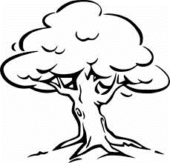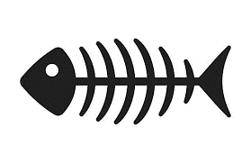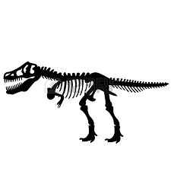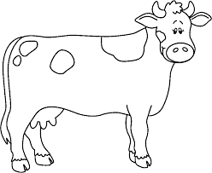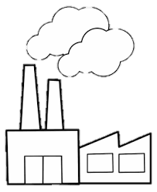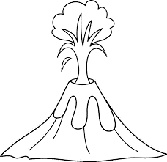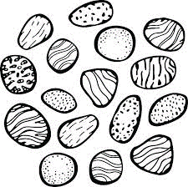
Water
Respiration
Photosynthesis
Decomposition
Decomposition
Decomposition
Precipitation
Respiration
Transpiration
n
Combustion
Respiration
Respiration
Geologic processes
Sediments
Land plants
Fossil fuels
Diffusion
Industry
Atmosphere
Land animals
Aquatic animals
Aquatic plants
Heat and pressure
Heat and pressure
Photosynthesis

