Ch. 19 Ecosystem Energy and Matter
Key Terms and Questions

Essential Question: How does energy and matter move through an ecosystem?
Key Terms
- Producer
- Herbivore
- Carnivore
- Omnivore
- Scavenger
- Decomposer
- Consumer
- Primary consumer
- Secondary consumer
- Tertiary consumer
- Food chain
- Food web
- Energy pyramid
Key Questions
- What does a producer do in an ecosystem?
- What does a consumer do in an ecosystem?
- What does a decomposer do in an ecosystem?
- How does energy move through an ecosystem?
- In what direction does energy flow in an ecosystem?
- Look at the diagram below.
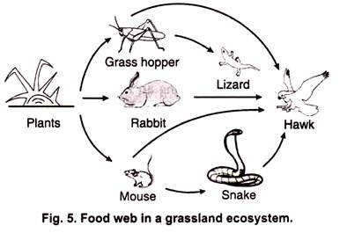
What is the producer?

Name 1 primary consumer?

Name 1 secondary consumer?

Name 1 tertiary consumer?

- Which level of a food web has the greatest number of organisms?
- Which level of a food web has the least number of organisms?
- Which level of a food web has the most energy?
- How much energy moves to the next level of a food web?

