Ch. 13 Forces that Shape the Earth Notes
Essential Question: How is the Earth stressed and what happens when it is?
- Stress – force that acts on rocks and change its shape or volume
  - Adds potential energy to rock until it changes shape or breaks
  - Types of Stress
    - Tension – pulls on crust stretching rock so it becomes thinner in the middle

    - Compression – squeezes rock until it folds or bends

    - Shear – pushes a mass of rock in two opposite directions

- Strain – a change in the shape of a rock cause by stress
  - Types of Strain
    - Elastic strain – change in rock that is not permanent
    - Plastic strain – creates permanent change in rock shape (usually when rocks are weak or hot)

- Landforms created by Compression
  - Mountain ranges – collision between 2 continental plates 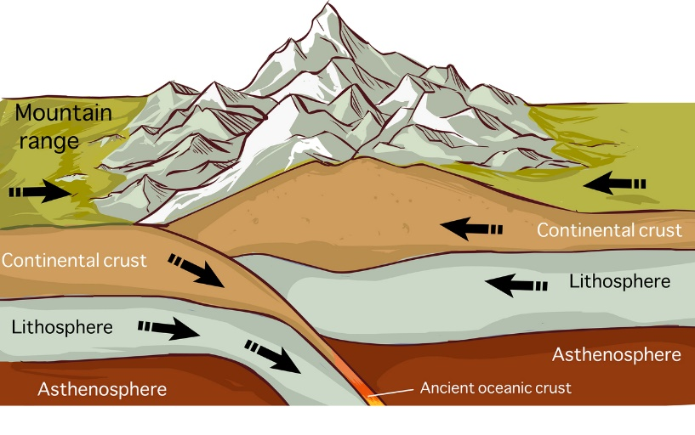
  - Ocean trenches – 1 plate goes under another

  - Volcanic arcs – curved line of volcanoes that form parallel to plate boundaries
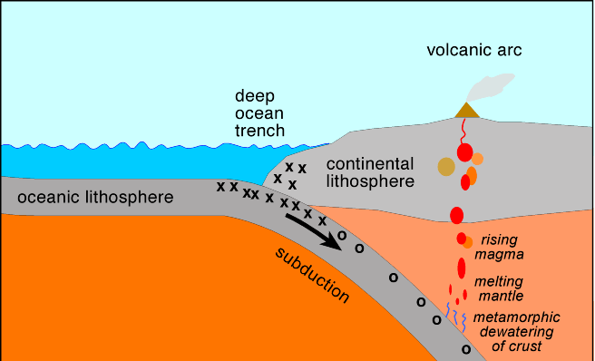

- Landforms created by Tension
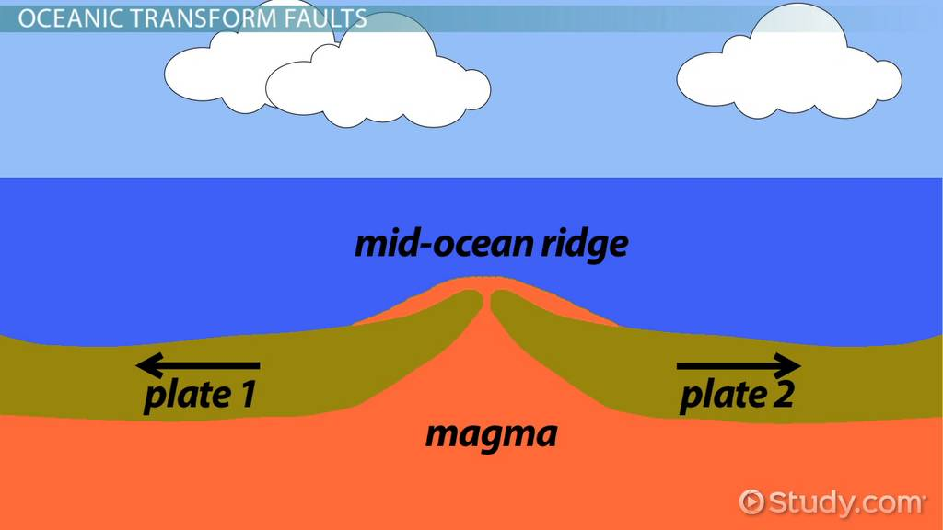
  - Mid ocean ridge – tension causes ocean crust to spread allowing hot rock from mantle to rise creating high ridges

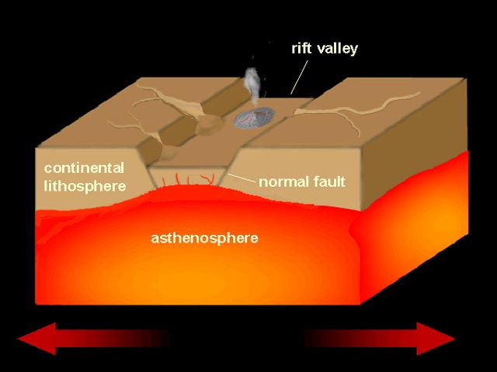
  - Continental rifts – when divergent boundaries occur within a continent, they cause splits in the crust.

- Landforms created by shearing
  - Fault – break in the crust
    - Transform faults – when plates slide horizontally past each other
    - Fault zones – an area of many fractured pieces of crust along a large fault

