Ch. 12 Plate Tectonics
Essential Question: What are three types of plate boundaries?
- Theory of Plate Tectonics
  - J. Tuzo Wilson (1965)
  - Lithosphere is broken into separate sections called plates.
  - Combined evidence about plates, continental drift and sea-floor spreading
  - Explains the formation, movement and subduction of Earth’s plates
  - Scientific theory - well tested idea that explains a wide range of observations.
- Theory Highlights
  - Plates float on asthenosphere
  - Convection currents rise toward and spread out under the lithosphere
  - Convection currents cause plates to move, making changes in Earth’s surface (volcanoes, earthquakes, mountain ranges, deep ocean trenches)
- Plate boundaries – the edges of plates where 2 plates meet.
  - Fault – rocks slipping past each other at a boundary
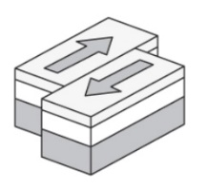
  - Types of boundaries
    - Transform boundary – 2 plates slip past each other moving in opposite directions
      - Frequent earthquakes
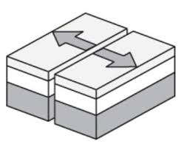
    - Divergent boundary – 2 plates move apart
      - Usually at mid-ocean ridge
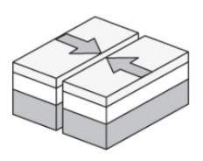
    - Convergent boundary – 2 plates move toward each causing a collision
      - 2 ocean plates or 1 ocean and 1 continental plate meet = subduction and formation of a trench
      - 2 continental plates = mountain formation

