Ch. 10 Motions within the Earth
Notes
- Convection in the mantle
  - 3 types of heat transfer
    - Radiation – heat energy transfer through empty space
    - Conduction – heat energy transfer through touching
    - Convection – transfer of heat energy by the movement of a heated fluid (liquids and gases)
      - Caused by differences in temperature and density in a fluid
      - Ex: Water heating on a stove: as water on bottom gets hot, it expands, becomes less dense and rises, when the surface of water starts cooling it becomes denser and moves to the bottom causing a convention current, or the flow that transfers heat.
  - Convection currents in the mantle
    - Heat source is the Earth’s core and mantle
    - Act as a conveyor belt moving the lithosphere
    - Going on for 4 billion years
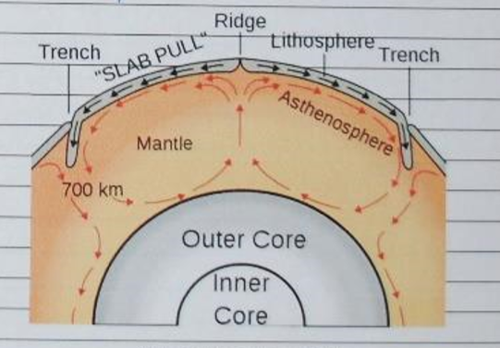
How it happens:
        - Density of lower mantle material is less than the dense than the mantle material around it and begins to rise
        - The rising mantle material hits the lithosphere and cannot go up any more
        - The force of gravity pulls down the risen mantle material that has now cooled and that material sinks
        - Heat from the core causes the temperature of mantle material to rise, decreasing density
        - The mantle material rises again.

