Ch. 10 Movement within the Earth
Key Terms and Questions
Key Terms
- convection
- magma
Key Questions
- Label the diagram of the layers of the Earth?

- What 2 things cause convection to occur within the Earth?
- In what layer does convection occur?
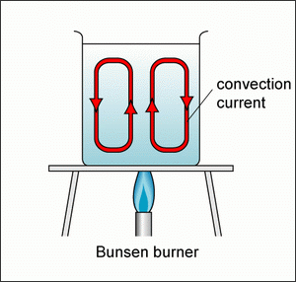
- Describe what happens at each step of a convection current as shown below.
- ________________________________
D
C
________________________________
E
B
________________________________
A
F
________________________________
- ________________________________
- ________________________________
- ________________________________
E. ________________________________

F. ________________________________
________________________________
________________________________
________________________________

